|  |
| --- |
| Architecture Design |
| Airline Administration System |
|  |

# Version table

|  |  |  |
| --- | --- | --- |
| Author: | Florin Deleanu 3784711 | Revision Date |
|  | Version 1 | April 2021 |
|  |  |  |

Contents

Back end design 1

Entity Relationship Diagram 2

C4 design Model 2

C2 Container Diagram 2

C3 Component Diagram 3

# Back end design

My backend uses a normal REST architecture which makes use of dependency injection to decide between concrete implementations of an interface.

The below structure is the norm although some classes skip the middle interface where we don’t need the dependency injection and use the database access interface directly.

The config class is needed to let java know which implementation of the repository interface we want to inject.

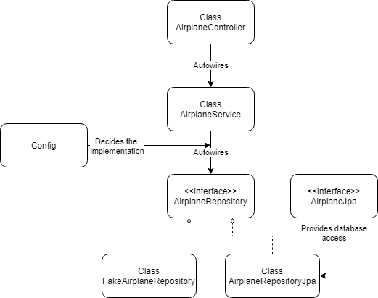

# Entity Relationship Diagram

This diagram shows the database architecture for my app. It is split into different tables that contain references to one another via foreign keys

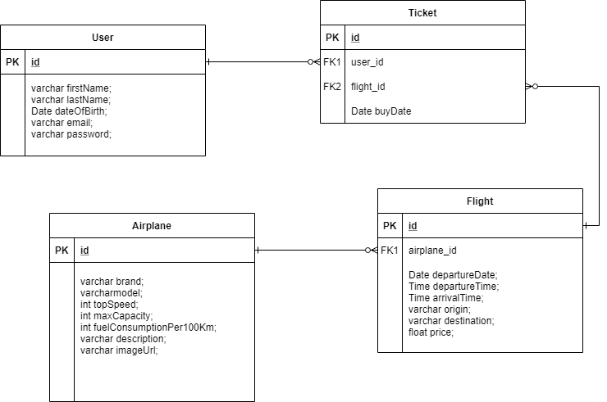

# Continuous integration diagram

This diagram shows how the Git CI pipeline works

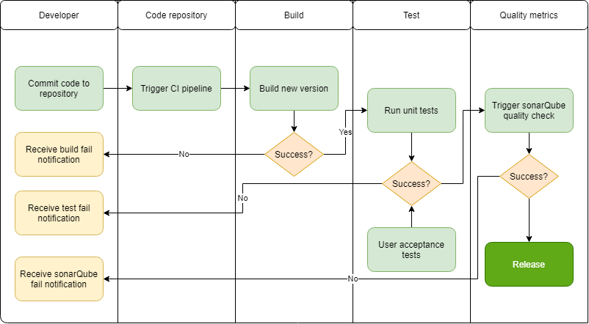

# C4 design Model

## C2 Container Diagram

The diagram separates the entire system into individual components such as a server application, a website app, a mobile app etc.

This diagram shows the containers from my application and their relation to one another

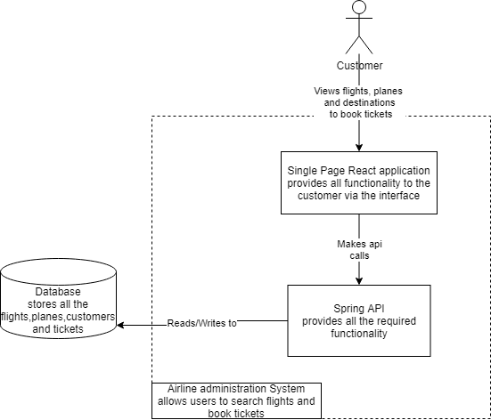

This application is a Java Spring Boot application with a React based front end which connects to an external MySql Database

## C3 Component Diagram

The component diagram looks further into the container and gives an overview of the controller components and their interactions. The simple overview is given in the diagram below.

The structure is subject to change when the app will grow more complex as the controllers will have common elements between them. How each controller functions is explained previously in the back-end architecture section.

